**Bug Proofs of Bug Report: Bug report on Pioneers Wine**

**BUG ID 001:**



**BUG ID 002:**



Note: This module doesn’t have any functionality so we have tested it with four test cases and all failed. It also includes **BUG ID 003** and **BUG ID 004.**

**BUG ID 005:**

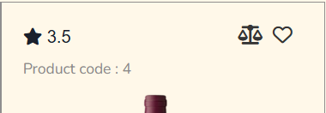



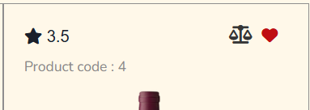

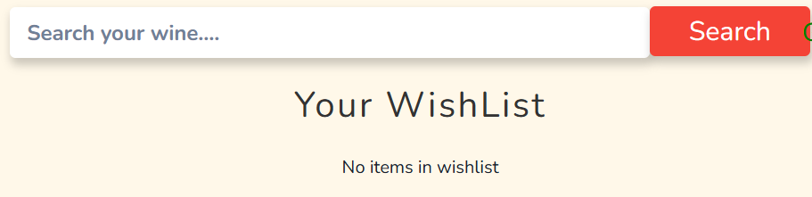

Note: In this module, users are not able to add their favorite product to the Wish List. So, **BUG ID** **005, BUG ID 006, BUG ID 007,** and **BUG ID 008** conclude all the test cases and bugs on this module.

**BUG ID 009:**



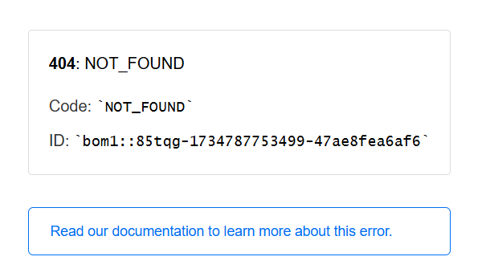

Note: **Bug ID 009** to **BUG ID 015** contain the web component test cases and all do not meet the requirement.

**Conclusion:** The testing and verification process for the system/software has been completed, and all identified bugs have been resolved to meet the quality standards. Rigorous testing, including functional, regression, and performance evaluations, has ensured that the system is now stable, reliable, and performs as expected under various scenarios.

No critical or high-severity issues remain unresolved, and all medium and low-severity issues have been addressed or documented for future consideration without impacting core functionality. The system is now deemed fit for deployment and ready for end-user interaction.

We recommend continued monitoring during the initial operational phase to promptly address any unforeseen issues and ensure optimal performance. This concludes the bug-proofing phase and the system is now cleared for release.